Intersections: Thinking Prompts

Intersections are different depending on your perspective:

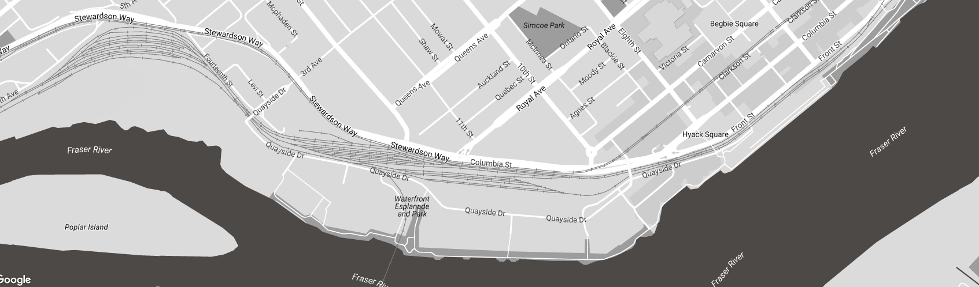

They can seem one way from far away and different up close:

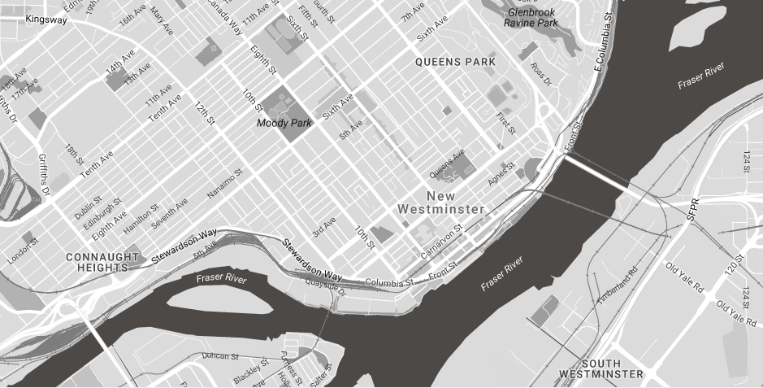

With each zoom in, we get a little more perspective as they move from purely angular to diffuse and lacking in congruency:

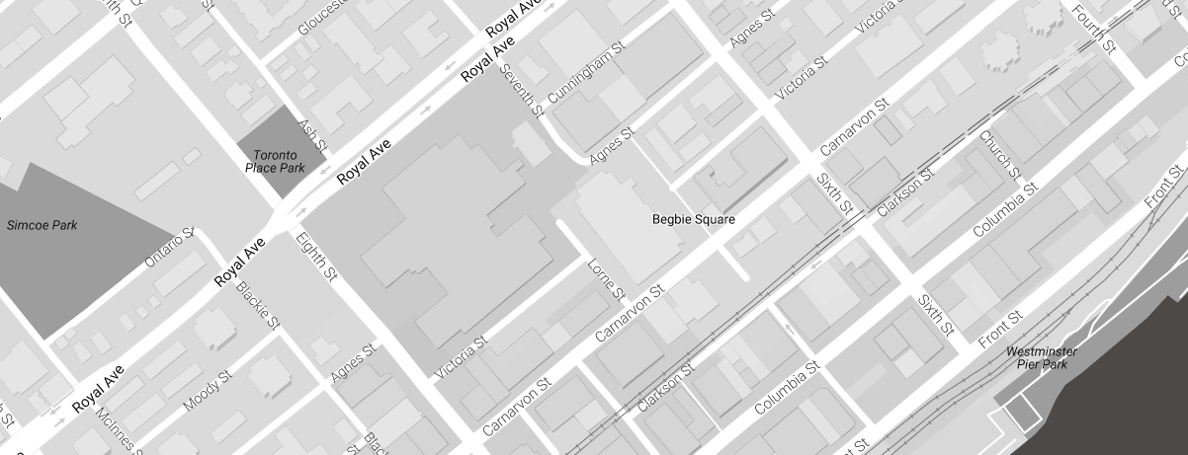

Notice how many fewer intersections feature the typical four-way intersection we think of:

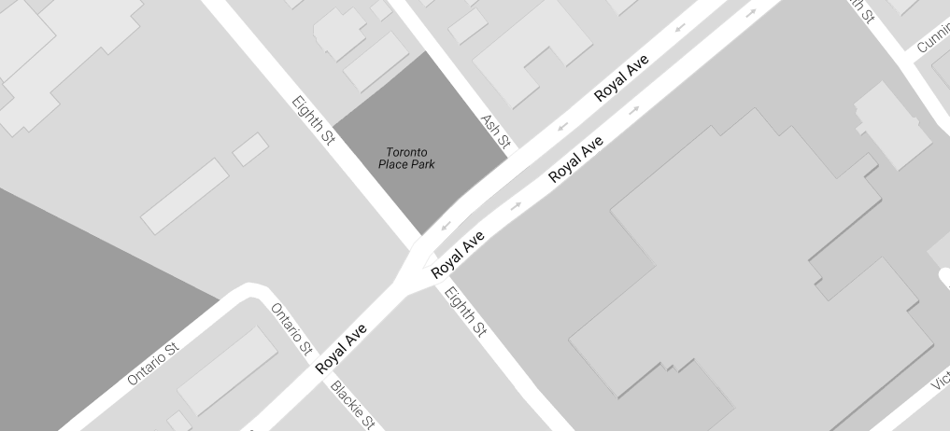

Think about how you would design lights and repurposed spaces for the intersection outside the main New Westminster campus.

Using these pieces of paper, how many types of intersection could you design? How might these straight lines be constraining the kinds of intersections you are designing? What needs consideration? What if the sheets of paper are sidewalks instead of roads?

Think about how you would design the lights

Disabilities, special needs, how do you accommodate?

When do you stop acoomodating

Think about intersections as a theoretical concepts

How can you disrupt the intersection – encouraging collisions? Between what parties?